SOLO Fortune Teller (after @MsHMFL)
Create a SOLO Fortune Teller for a topic you are studying using the prompts in the template below.
Identify  [insert: image, data, text, symbol ] | [insert: identity of image, data, text, symbol ] | [insert: identity image, data, text, symbol ]  age]  [insert: image, data, text, symbol ] | Bring in ideas  Describe
[insert: identity of image, data, text, symbol ]  [insert: image, data, text, symbol ] |  | [insert: identity of image, data, text, symbol ]  age] | [insert: image, data, text, symbol ]
[insert: identity of image, data, text, symbol ]  age]  [insert: image, data, text, symbol ] | [insert: identity of image, data, text, symbol ]  age] | [insert: identity of image, data, text, symbol ]  age]  [insert: identity of image, data, text, symbol ]  age] | [insert: image, data, text, symbol ]
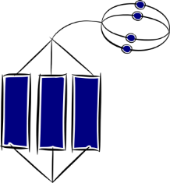  Extend ideas  Generalise, evaluate, predict, reflect | [insert: image, data, text, symbol ] | [insert: image, data, text, symbol ] | Link ideas  Explain cause/effect, compare

Ask your partner to …
- Choose an image, data, text or symbol
- Identify the image, data, text or symbol [idea]
- Bring in ideas – e.g. describe the attributes of the image data, text or symbol [ideas]
- Link idea – e.g. explain cause/effect, compare [relate]
- Extend ideas – e.g. generalise, evaluate, reflect, predict [extend]

